**Energy Efficiency Analytics - Manufacturing Sector**

GOKULNATH K & E24755

**Overview**

Energy efficiency analytics in the manufacturing sector focuses on optimizing energy consumption through data-driven insights. By implementing advanced analytics and smart manufacturing technologies, companies can monitor real-time energy usage, identify inefficiencies, and forecast consumption patterns. These analytics enable manufacturers to make informed decisions that enhance operational efficiency and reduce costs, ultimately contributing to sustainability goals. As energy costs rise and environmental regulations tighten, leveraging data analytics becomes essential for maintaining competitiveness in the industry.

**Objective**

1. **Identify Energy Consumption Patterns:** Analyze data to uncover trends and inefficiencies in energy usage.
2. **Optimize Operational Efficiency:** Use predictive analytics to forecast energy needs and enhance manufacturing processes.
3. **Benchmark Performance:** Establish KPIs to measure and compare energy efficiency against industry standards.
4. **Facilitate Real-time Monitoring:** Implement IoT solutions for immediate insights into energy consumption and anomalies.
5. **Support Decision-Making:** Provide actionable intelligence for informed energy management strategies.
6. **Enhance Sustainability Goals:** Align initiatives with sustainability objectives to reduce waste and emissions.
7. **Reduce Operational Costs:** Identify areas for energy savings to lower utility expenses.

**Assigned Task(s)**

* Energy Efficiency Analytics - Manufacturing Sector.
* **Status:** Completed.
* **Details:**

1. Energy Consumption with Machine ID: Analyzed energy consumption metrics for each machine ID to assess individual performance.
2. Correlation Analysis: Conducted correlation analysis to explore relationships between energy consumption and production output.
3. Energy Consumption Shift-wise: Evaluated energy consumption patterns across different shifts to identify variations in usage.
4. Production Output Shift-wise: Analyzed production output data by shift to understand productivity levels during different operational hours.
5. Efficiency Analysis by Machine: Performed efficiency analysis for each machine to identify areas for improvement in energy utilization.
6. Summarizing Total Operating Hours by Shift: Compiled total operating hours for each shift to evaluate labor and equipment usage.
7. Energy Cost per kWh by Shift: Assessed energy cost per kWh for each shift to analyze the financial impact of energy consumption across different operational periods.

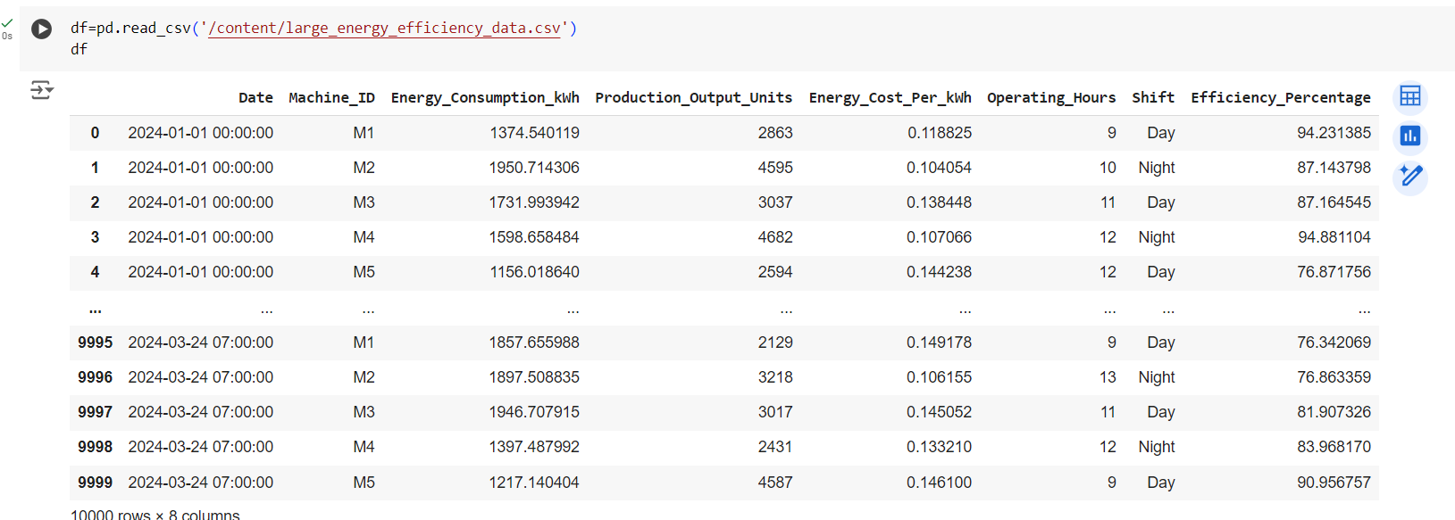

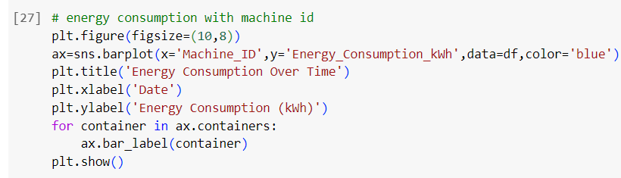

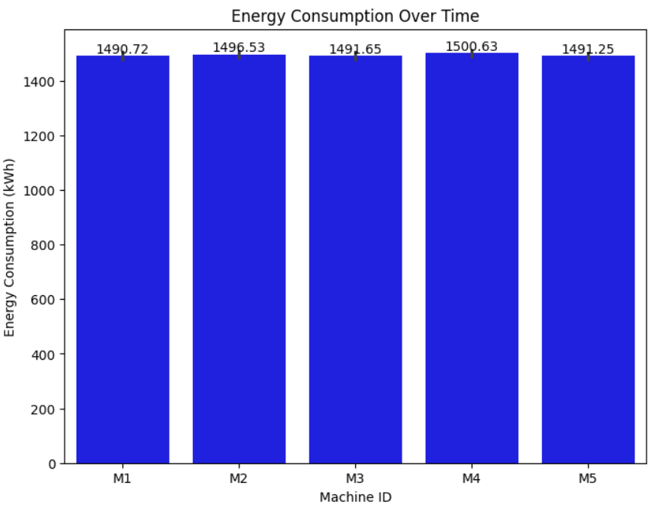

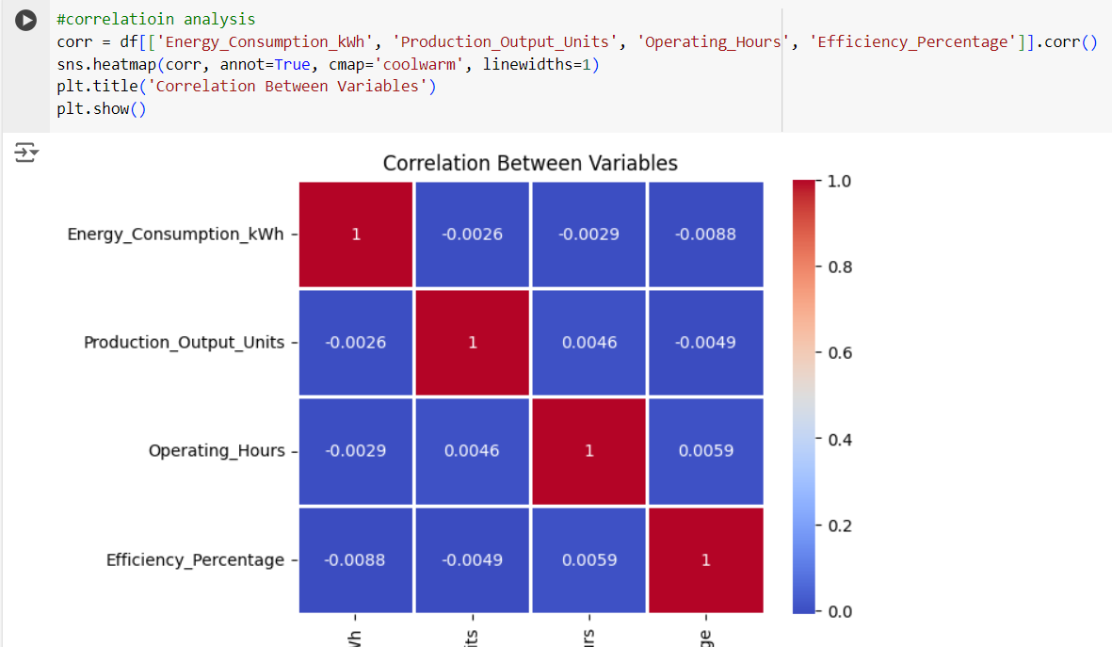

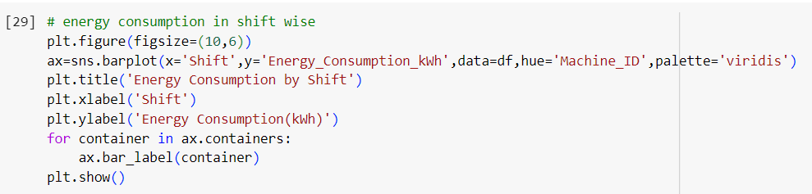

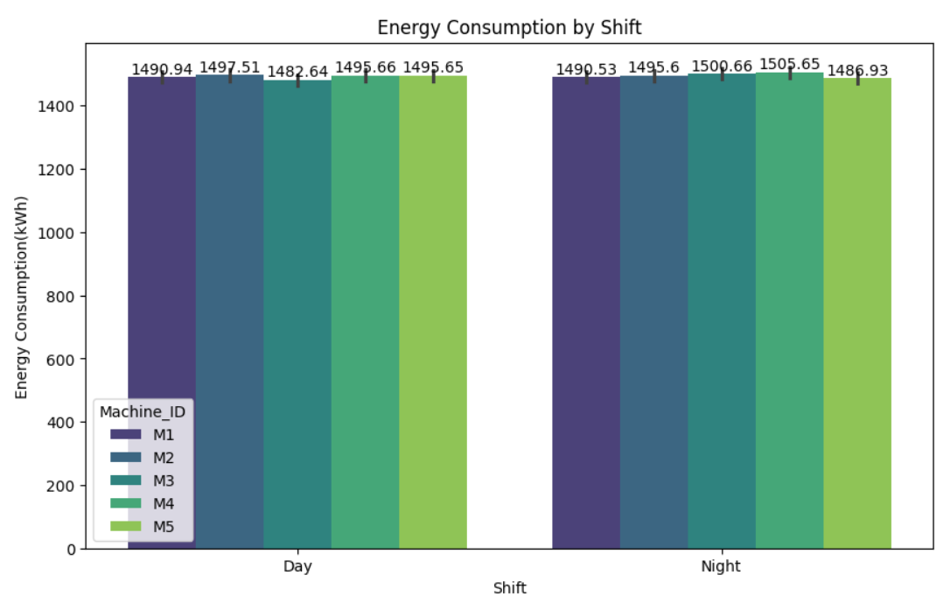

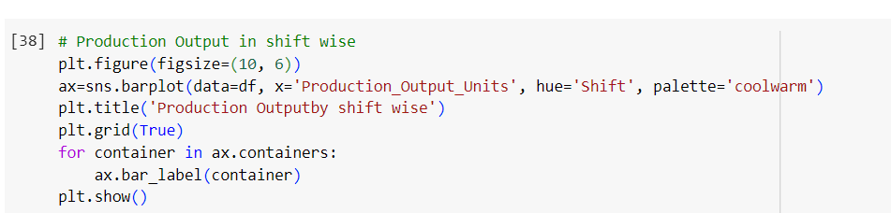

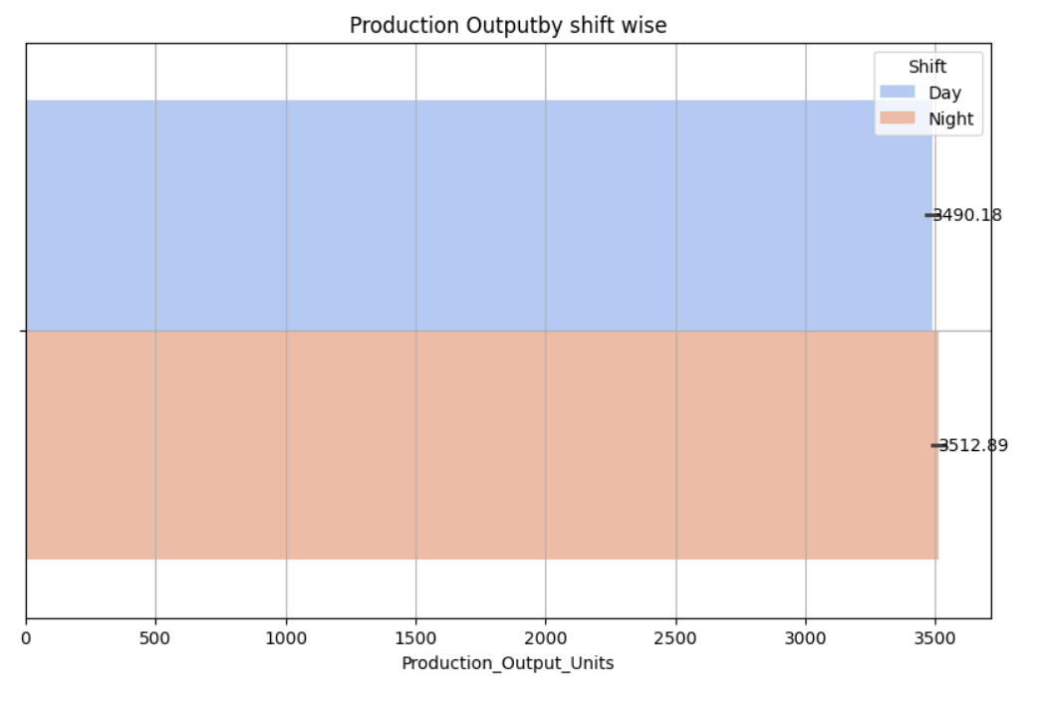

**Progress**

* **Accomplishments:**

1. Analyzed Machine Performance: Evaluated energy consumption by machine ID, identifying high and low performers.
2. Revealed Key Relationships: Conducted correlation analysis between energy consumption and production output.
3. Identified Shift Patterns: Assessed energy consumption and production output shift-wise for optimized resource allocation.
4. Improved Efficiency: Performed machine efficiency analysis, pinpointing areas for energy optimization.
5. Summarized Operating Hours: Compiled total operating hours by shift to enhance workforce management.
6. Financial Insights: Analyzed energy cost per kWh by shift, supporting informed budget management.

* **Metrics:**

1. Total Energy Consumption: Overall energy usage by each machine, measured in kWh.
2. Production Output: Total units produced per machine and shift, highlighting productivity levels.
3. Efficiency Ratio: Energy consumption relative to production output, indicating machine efficiency.
4. Average Operating Hours: Total operating hours aggregated by shift to assess workforce utilization.
5. Cost per kWh: Energy costs calculated per kWh for each shift, facilitating financial analysis.
6. Shift-wise Consumption: Energy usage metrics categorized by shift to identify consumption patterns.
7. Correlation Coefficient: Statistical measure indicating the strength and direction of the relationship between energy consumption and production output.

**Challenges and Solutions**

* **Challenges Faced:**

1. Inconsistent or incomplete data on energy consumption and production metrics can hinder accurate analysis.
2. Variability in energy costs can affect budgeting and financial forecasting.

* **Solutions Implemented:**

1. Implement data cleaning and validation processes to ensure data integrity and completeness before analysis.
2. Implement dynamic modeling tools to better predict energy costs based on historical trends and market conditions.

**Next Steps**

* **Upcoming Tasks:** Tackle upcoming tasks in manufacturing by using data for decisions, and encouraging teamwork.
* **Goals:** Develop your skills, focus on continuous learning through relevant online courses, hands-on projects, and staying updated with industry trends and technologies.

**Conclusion**

* **Summary:** The analysis of energy consumption and production efficiency in the manufacturing sector highlights critical insights for optimizing performance and reducing costs. By examining metrics such as machine performance, shift-wise consumption, and energy costs, organizations can make informed decisions that enhance operational effectiveness. Implementing data-driven strategies will support sustainable practices and drive continuous improvement in manufacturing processes.
* **Acknowledgements:** Thank you all for your attention and engagement, I appreciate your interest in the Energy Efficiency Analytics - Manufacturing Sector.